

**University Of Asia Pacific**

**Department Of Computer Science And Engineering**

Course Title: Database Systems Lab

Course Code: CSE 212

Project Name: Train Management System

|  |  |  |
| --- | --- | --- |
| Submitted By | Submitted To | |
| |  |  | | --- | --- | | Name | ID | | Md Noushad Jahan Ramim  Junaid Abedin Rafi | 22201257  22201265 |   Section: E-2  Year-Semeter:2nd Year-2nd Semester | | Alif Ruslan  Lecturer  Department Of Computer Science and Engineering  University of Asia Pacific |

**Table of Content**

**1.Topic..................................................................................................3 2.Description........................................................................................3 3.DatabaseName..................................................................................4 4.Users..................................................................................................5 5.Table..................................................................................................5 6.TableColumn/Attribute....................................................................6 7.PrimaryKey,ForeignKeyRelation.................................................7 8.EntityRelation.................................................................................10 9.ERDiagram.....................................................................................11 10.SchemaDiagram...........................................................................12 11.Queries...........................................................................................13**

**CEP Mapping……………………………………………………..19**

**Train Management System**

**Topic**

The **Train Management System (TMS)** is an innovative solution designed to make train operations smoother and more efficient. This system leverages technology to manage crucial aspects such as train schedules, ticket bookings, route planning, and passenger information. With real-time data tracking, TMS ensures that both passengers and operators have access to accurate and up-to-date information, improving overall reliability.

TMS is especially important in today’s fast-paced world, where growing urban populations and increasing demand for public transportation put pressure on existing systems. By automating key processes and optimizing resource usage, TMS not only saves time and reduces operational costs but also enhances passenger satisfaction.

The system is built to support scalability and future advancements, such as real-time GPS tracking and predictive analytics. Tools like TMS are essential for modernizing transportation infrastructure, making it smarter, more sustainable, and capable of meeting the needs of a rapidly growing population.

**Description**

The **Train Management System (TMS)** is a centralized platform designed to efficiently manage and optimize railway operations. This system streamlines critical processes like ticket booking, train scheduling, route planning, and passenger data management, ensuring smoother operations and enhanced user experiences. Here's a detailed look at what the TMS offers:

1. **Train Scheduling and Route Management**:  
   TMS provides real-time data to optimize train schedules and routes, reducing delays and improving operational efficiency. It considers factors like train capacity, track availability, and traffic conditions to minimize disruptions.
2. **Passenger Information Management**:  
   The system maintains a comprehensive database of passenger data, including booking records and travel preferences, ensuring smooth ticketing and personalized services.
3. **Ticket Booking and Reservation**:  
   TMS automates ticket booking processes, offering both online and offline platforms for convenience. It also ensures secure payment gateways and a seamless reservation experience.
4. **Operational Analytics**:  
   Leveraging data-driven analytics, the system generates insights into operational performance. It helps identify areas for improvement, such as reducing fuel consumption, enhancing train punctuality, and improving passenger satisfaction.
5. **Maintenance and Resource Optimization**:  
   TMS tracks train conditions, monitors maintenance schedules, and ensures that resources like fuel, manpower, and equipment are utilized efficiently.

**Core Benefits of TMS:**

* **Enhanced Efficiency**: Automates processes, saving time and reducing errors.
* **Improved Passenger Experience**: Offers real-time updates, streamlined ticketing, and better services.
* **Sustainability**: Optimizes resource use and promotes eco-friendly practices.
* **Data-Driven Decisions**: Provides actionable insights to improve operations and service delivery.
* **Scalability and Future Integration**: Ready for integration with advanced features like GPS tracking and mobile applications.

Database Name

The database for the **Train Management System (TMS)** is called **"Train_Management_System_DB"** and is designed to organize and manage railway-related data efficiently. It will consist of **8 interconnected tables**, each catering to specific aspects of railway operations. This database serves as the system's backbone, acting as a centralized platform to streamline train scheduling, ticketing, and resource allocation.

User

The Train Management System (TMS) serves multiple stakeholders to streamline train operations and enhance passenger experience.  
Key users include:

1. **Passengers**
   * Access train schedules, ticket availability, and fare details.
   * Book, modify, or cancel tickets and track journey history.
2. **Train Operators**
   * Manage train details, including adding or updating schedules and assigning personnel.
   * Monitor train operations to ensure smooth service delivery.
3. **Station Managers**
   * Oversee station activities, including platform assignments and schedule adjustments.
   * Handle operational issues such as delays and platform changes.
4. **Maintenance Teams**
   * Schedule and log maintenance activities for trains and stations.
   * Ensure infrastructure safety by updating inspection and repair records.
5. **Administrators**
   * Manage user access, maintain system security, and oversee database integrity.
   * Ensure compliance with operational guidelines and monitor system activities.
6. **Central Data Management Team**
   * Manage the database, ensure data consistency, and run queries.
   * Generate analytical reports to support decision-making and improve operations.

Table

1. Stations

2. Trains

3. Passengers

4.TrainDelays

5.AlternativePaths

6. Tickets

7. Complaints

8. Employees

**Columns /Attributes**

1. Stations(StationID,StationName,Location)

2.Trains(TrainID,TrainName,SourceStationID,DestinationStationID,DepartureTime,ArrivalTime)

3.Passengers(PassengerID,FirstName,LastName,Age,Gender,Email,PhoneNumber,TrainID)

4.TrainDelays(DelayID,TrainID,DelayReason,DelayDuration,Date)

5.AlternativePaths(PathID,MissedTrainID,AlternativeTrainID,Description)

6. Tickets(TicketID,PassengerID,TrainID,Fare,DateOfTravel)

7.Complaints(ComplaintID,PassengerID,ComplaintText,DateOfComplaint)

8.Employees(EmployeeID,EmpName,Role,StationID,ContactNumber,Salary,DateOfjoining)

**Primary Key, Foreign Key/Relation**

**1. Stations Table**

* **Primary Key:** StationID

**2. Trains Table**

* **Primary Key:** TrainID
* **Foreign Key / Relation:**
  + SourceStationID **FOREIGN KEY** references Stations(StationID)
  + DestinationStationID **FOREIGN KEY** references Stations(StationID)

**3. Passengers Table**

* **Primary Key:** PassengerID
* **Foreign Key / Relation:**
  + TrainID **FOREIGN KEY** references Trains(TrainID)

**4. TrainDelays Table**

* **Primary Key:** DelayID
* **Foreign Key / Relation:**
  + TrainID **FOREIGN KEY** references Trains(TrainID)

**5. AlternativePaths Table**

* **Primary Key:** PathID
* **Foreign Key / Relation:**
  + MissedTrainID **FOREIGN KEY** references Trains(TrainID)
  + AlternativeTrainID **FOREIGN KEY** references Trains(TrainID)

**6. Tickets Table**

* **Primary Key:** TicketID
* **Foreign Key / Relation:**
  + PassengerID **FOREIGN KEY** references Passengers(PassengerID)
  + TrainID **FOREIGN KEY** references Trains(TrainID)

**7. Complaints Table**

* **Primary Key:** ComplaintID
* **Foreign Key / Relation:**
  + PassengerID **FOREIGN KEY** references Passengers(PassengerID)

**8. Employees Table**

* **Primary Key:** EmployeeID
* **Foreign Key / Relation:**
  + StationID **FOREIGN KEY** references Stations(StationID)

Entity Relationship

|  |  |  |  |  |
| --- | --- | --- | --- | --- |
| Entity Name 1 | Entity Name 2 | Relationship Name | Relationship Type | Participation |
| Train | Stations | Located At | Many-to-One | Total for Trains, Partial for Stations |
| Train | TrainDelays | Experience Delay | One-to-Many | Partial for Trains, Total for TrainDelays |
| Train | AlternativePaths | Has | One-to-Many | Partial for Trains, Partial for AlternativePaths |
| Passenger | Complaints | Submit | One-to-Many | Partial for Passengers, Total for Complaints |
| Passenger | Tickets | Buys | One-to-Many | Total for Passengers, Partial for Tickets |
| Train | Tickets | For | One-to-Many | Partial for Trains, Total for Tickets |
| Passenger | Trains | Travels On | Many-to-Many | Partial for both |
| Employees | Stations | Works At | Many-to-One | Partial for Employees, Partial for Stations |

ER Diagram

Train Management System

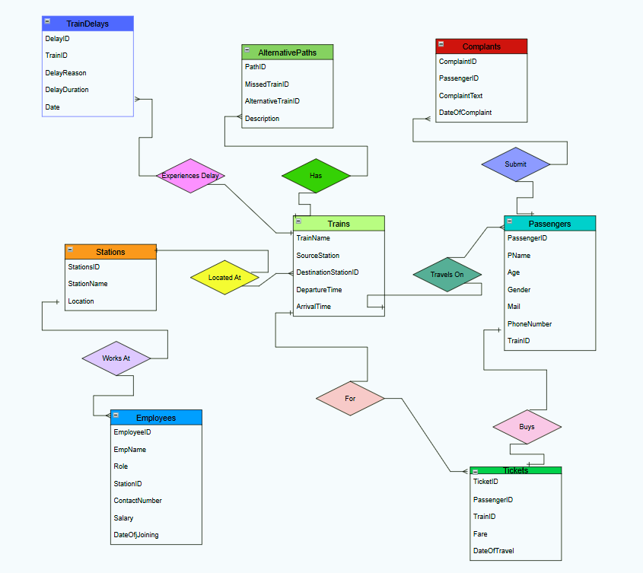

Schema Diagram

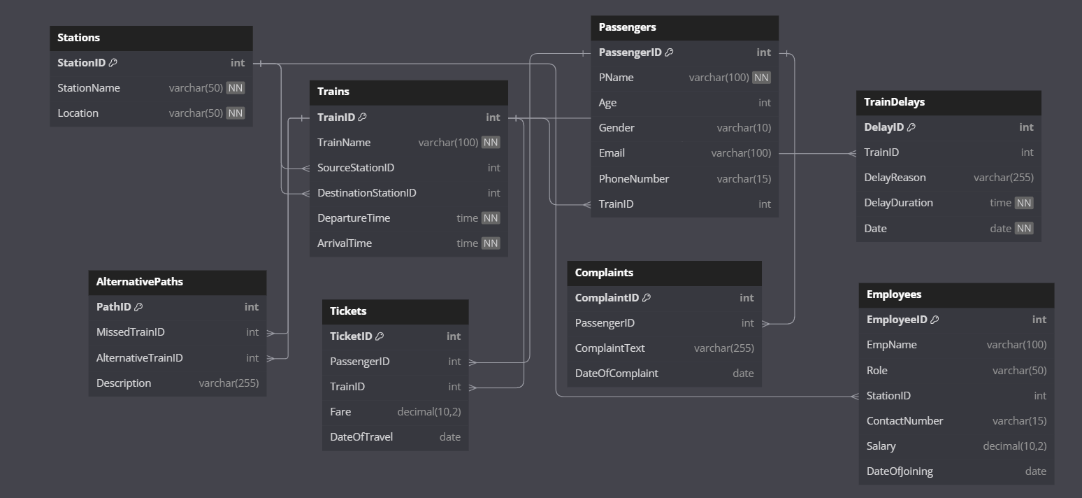

**Queries**



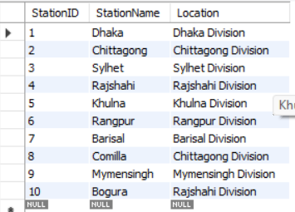



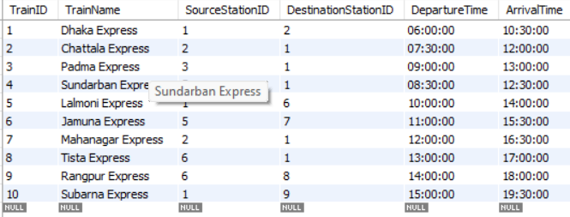

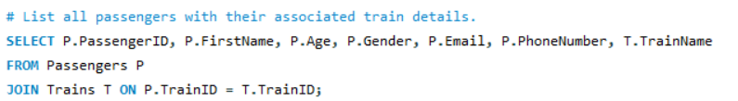

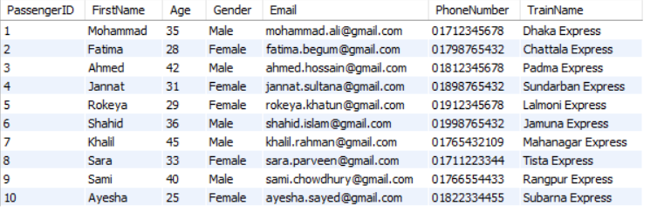

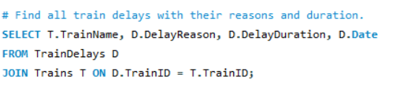

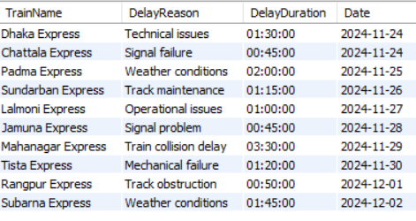

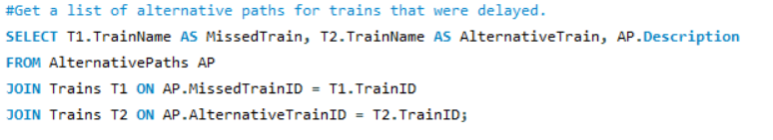

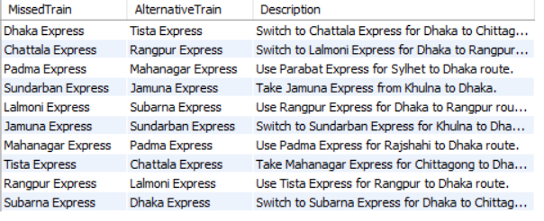

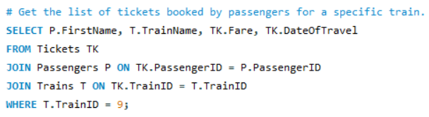

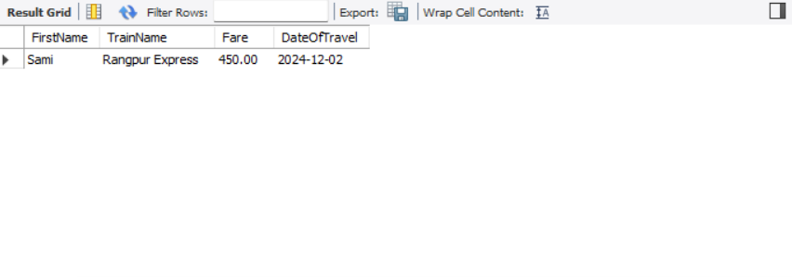

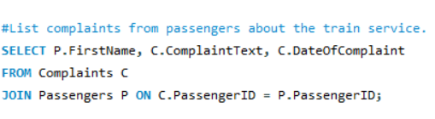

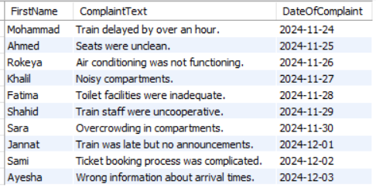

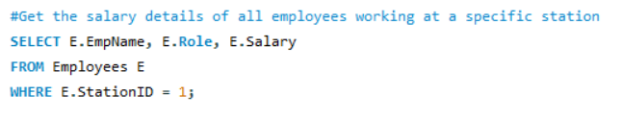

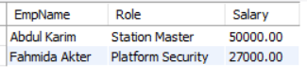

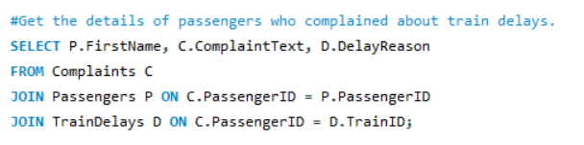

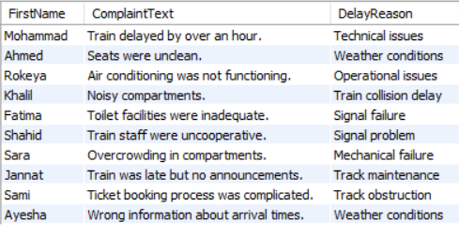

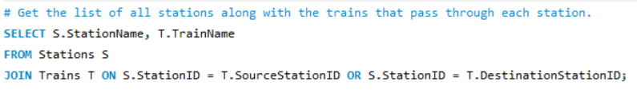

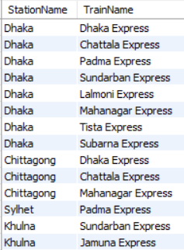

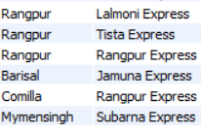

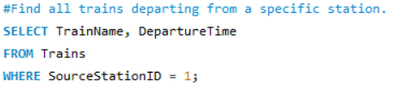

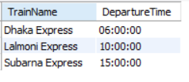

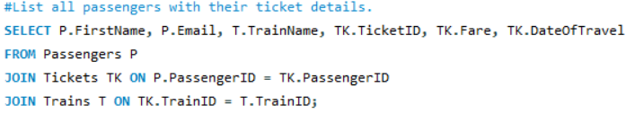

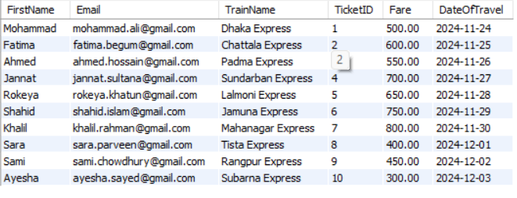

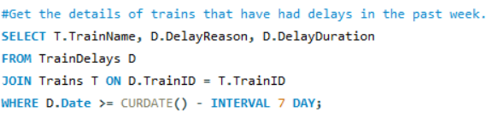

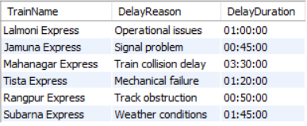

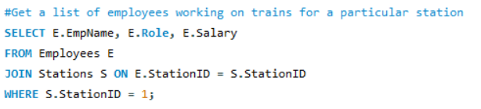

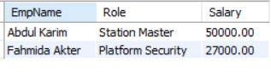

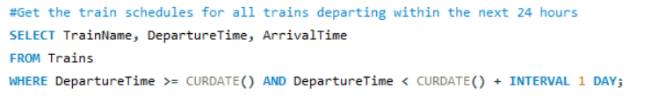

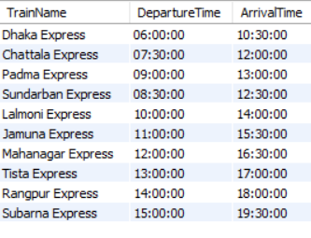

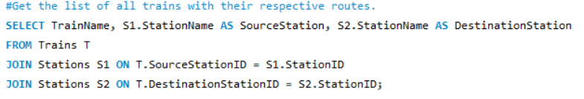

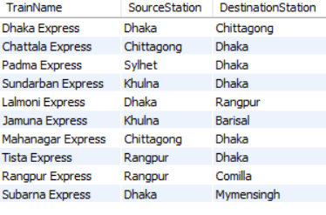

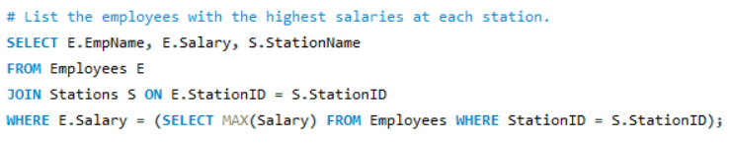

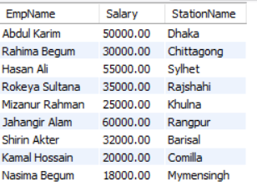

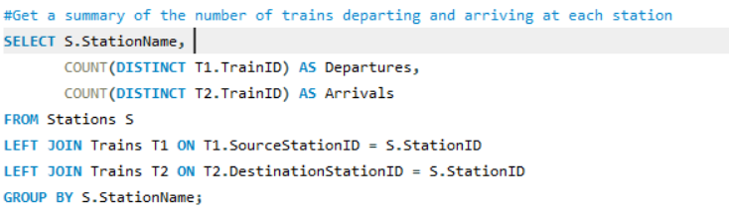

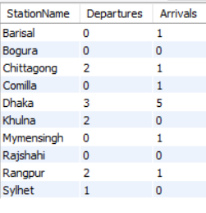

CEP mapping

Our project addresses a **complex engineering problem** because it involves managing diverse data for efficient train scheduling, ticket booking, and resource management. It requires in-depth engineering knowledge and abstract thinking, particularly in database modeling and SQL. The project also involves multiple stakeholders, including passengers, railway authorities, and station staff, with varying requirements.

🡪How Knowledge Profiles(K’s) are addressed through the project and mapping among

K’s, Cos and POs:

|  |  |  |  |  |
| --- | --- | --- | --- | --- |
| CODE | Competency | Description | Related Courses | Related POs |
| K3 | Engineering Fundamentals | Utilized core engineering principles such as relational database design, SQL, and system analysis to create an efficient train management system | CO1, CO2, CO3 | PO1, PO2 |
| K4 | Specialist Knowledge | Required expertise in transport systems and data management to design an optimized database for train schedules, tickets, and passenger data. | CO4, CO5, CO6 | PO6, PO8 |
| K5 | Engineering Design | Designed ER diagrams, normalized database schemas, and implemented logical relationships between entities such as trains, routes, and passengers. | CO3, CO7, CO8 | PO3, PO2 |
| K6 | Interdisciplinary Knowledge | Integrated transport management knowledge with database engineering, addressing real-world challenges in scheduling and resource allocation. | CO9, CO10 | PO5, PO9 |

**How Complex Engineering Problem Solving (P’s) are addressed through the project and mapping among P’s, COs, and POs**:

|  |  |  |  |  |
| --- | --- | --- | --- | --- |
| Code | Performance | Description | Related Courses | Related POs |
| P1 | Practical Implementation | Developed a fully functional database system using SQL, including automation for ticket booking and train scheduling. | CO3, CO5 | PO2, PO5 |
| P2 | Problem-Solving Skills | Solved real-world challenges such as conflict resolution in train schedules and automated ticket availability based on route capacity. | |  | | --- | | CO6, CO7 |  |  | | --- | |  | | PO4, PO8 |
| P3 | Data Analysis and Insights | Designed tables to store, process, and analyze train schedules, passenger bookings, and station data for better decision-making. | CO4, CO9 | PO6, PO8 |
| P4 | Technology Integration | Integrated real-time train tracking and ticket availability updates into the database, improving decision-making and passenger experience | CO10 | PO7, PO12 |

**How Complex Engineering Activities (A’s) are addressed through the project and mapping among A’s, COs, and POs**:

|  |  |  |  |  |
| --- | --- | --- | --- | --- |
| Code | Attributes | Description | Related Courses | Related POs |
| A1 | Teamwork and Collaboration | Collaborated with team members to design and implement the database, leveraging diverse expertise in programming and transport systems. | CO8, CO11 | PO7, PO10 |
| A2 | Ethical Responsibility | Ensured ethical data usage by protecting passenger information and providing transparent scheduling and ticketing systems. | CO12 | PO9, PO11 |
| A3 | Adaptability and Innovation | Applied innovative methods such as route optimization and developed a flexible system capable of adapting to new train routes and schedules. | CO5, CO10 | PO8, PO12 |